**Goal 1:** Find the number of taxi rides for each taxi company for November 15-16, 2017. Sort the results by amount of trips in descending order.

**Code:**

SELECT

cabs.company_name AS company_name,

COUNT(trips.trip_id) AS trips_amount

FROM cabs

INNER JOIN trips ON trips.cab_id = cabs.cab_id WHERE

trips.start_ts::date BETWEEN '2017-11-15' AND '2017-11-16' GROUP BY company_name ORDER BY

trips_amount DESC;

**Results:**

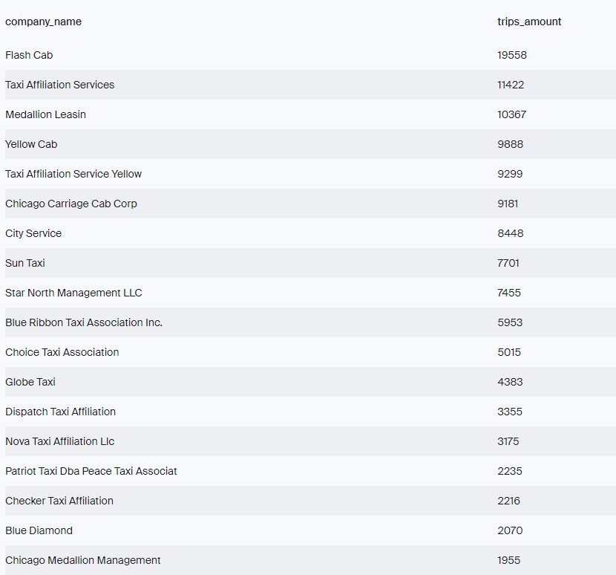

**Goal 2:** Find the number of rides for every taxi company whose name contains the words "Yellow" or "Blue" for November 1-7, 2017. Group the results by company name.

**Code:**

SELECT

cabs.company_name AS company_name,

COUNT(trips.trip_id) AS trips_amount FROM cabs

INNER JOIN trips ON trips.cab_id = cabs.cab_id

WHERE

(cabs.company_name LIKE '%Yellow%'

OR cabs.company_name LIKE '%Blue%')

AND trips.start_ts::date BETWEEN '2017-11-01' AND '2017-11-07' GROUP BY company_name;

**Results:**

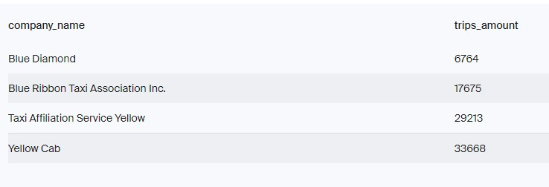

**Goal 3:** Find the number of rides for the two most popular companies. Join the rides for all other companies in the group "Other." Group the data by taxi company names. Sort the result in descending order by the amount of trips.

**Code:**

SELECT

CASE

WHEN cabs.company_name = 'Flash Cab' THEN 'Flash Cab'

WHEN cabs.company_name = 'Taxi Affiliation Services' THEN

'Taxi Affiliation Services'

ELSE 'Other'

END AS company,

COUNT(trips.trip_id) AS trips_amount FROM cabs

INNER JOIN trips ON trips.cab_id = cabs.cab_id WHERE

trips.start_ts::date BETWEEN '2017-11-01' AND '2017-11-07' GROUP BY company ORDER BY

trips_amount DESC;

**Results:**

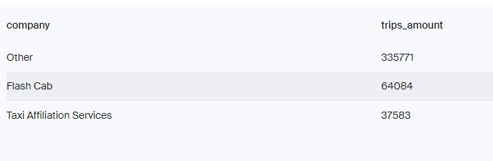

**Goal 4:** Retrieve the identifiers of the O'Hare and Loop neighborhoods.

**Code:**

SELECT neighborhood_id, name FROM neighborhoods WHERE name LIKE 'Loop'

OR name LIKE '%Hare';

**Results:**

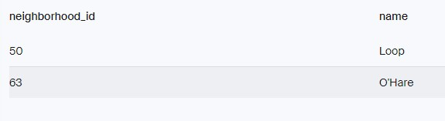

**Goal 5:** For each hour, retrieve the weather condition records. Break all hours into two groups: Bad if the description field contains the words rain or storm, and Good for others.

**Code:**

SELECT

DATE_TRUNC('hour', ts::timestamp) AS date_and_hour,

CASE

WHEN description LIKE '%rain%' THEN 'Bad'

WHEN description LIKE '%storm%' THEN 'Bad'

ELSE 'Good'

END AS weather_conditions FROM weather_records GROUP BY date_and_hour, weather_conditions ORDER BY date_and_hour;

**Results:**

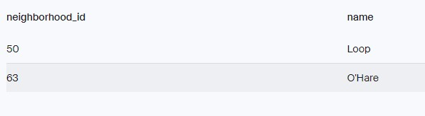

**Goal 6:** Retrieve all the rides that started in the Loop on a Saturday and ended at O'Hare. Get the weather conditions for each ride. Also, retrieve the duration of each ride. Ignore rides for which data on weather conditions is not available. Sort by trip id.

**Code:**

SELECT

trips.start_ts AS start_ts,

CASE

WHEN weather_records.description LIKE '%rain%' THEN 'Bad'

WHEN weather_records.description LIKE '%storm%' THEN 'Bad'

ELSE 'Good'

END AS weather_conditions,

trips.duration_seconds AS duration_seconds FROM trips

INNER JOIN weather_records ON weather_records.ts = trips.start_ts WHERE

trips.pickup_location_id = '50' AND trips.dropoff_location_id = '63'

AND EXTRACT(DOW FROM trips.start_ts) = 6 ORDER BY trips.trip_id;

**Results:**

